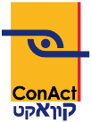
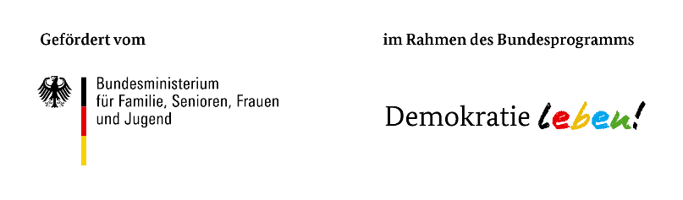
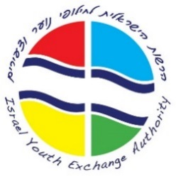
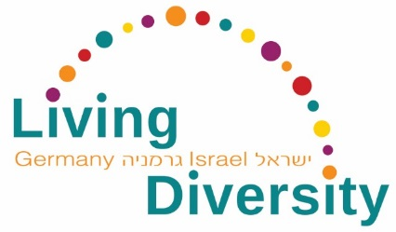

“Living Diversity in Germany and Israel –
Challenges and Perspectives for Education and Youth Exchange”

Living Diversity in Education
Leipzig, September 11 –15, 2017

Application form

First name and surname*
Organization*
Position*
Address*
Date of birth*
E-Mail*
Phone number*

Special Food Preference
Vegetarian
Vegan

What is your motivation to participate in this program? *

What are the key aspects and focus points of the activities in your institution or field of work? *

Which role does diversity play in your field of work (among others: cultural; religious; ethnic; social; sexual; physical and mental diversity)? *

Have you had previous experience with the offered methods? (several answers possible)
Social Justice
Betzavta/More Than One Democracy
Αnti-Bias

Notes

Data privacy statement

I hereby agree that the data given in my registration – name, last name, name of my institution, address as well as my email address – will be used for setting up the list of participants and will be available for all participants of the seminar. *
Yes
No

I agree to pictures taken at the seminar which include me, being used by ConAct for the purpose of their public relations work (e.g. reports, documentation of the seminar, website). *
Yes
No

Hereby I bindingly register myself for the chosen seminar and I agree to ConAct saving my data electronically for the purpose of their work. The above information will not be distributed to third parties. *
Yes

Send your application by August 10, 2017 to
Israel Youth Exchange Authority
Tel. 03-6969390 Karina@youthex.co.il

