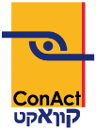
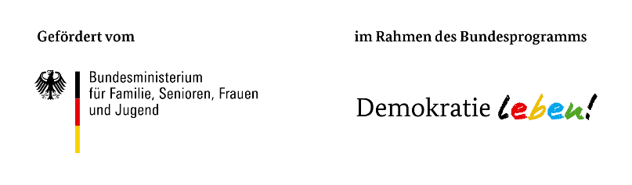
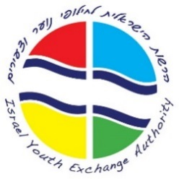
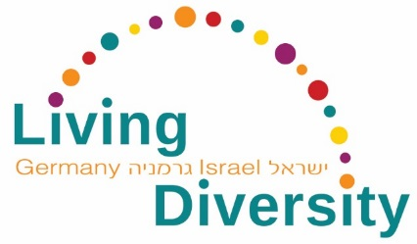

“Living Diversity in Germany and Israel –
Challenges and Perspectives for Education and Youth Exchange”

Living Diversity in Youth Exchange
Training program for German-Israeli Youth Exchange
Mainz, November 13 – 17, 2017

Application form

* Please fill out the following fields:
Surname*
First name*
Organization*
Position*
Zipcode / City*
Address*
Date of birth*
E-mail*
Phone number*

Special Food Preference or Food Intolerances
Vegetarian
Vegan
Other, namely:

What is your motivation to participate in this program?*

Did you participate previously in a German-Israeli youth exchange?*
Yes
No

Did you organize a German-Israeli youth exchange or accompanied one as a teamer?*
Yes
No

Notes

Data privacy statement

I hereby agree that the data given in my registration – name, last name, name of my institution, address as well as my email address – will be used for setting up the list of participants and will be available for all participants of the seminar.*
Yes
No

I agree to pictures taken at the seminar which include me, being used by ConAct for the purpose of their public relations work (e.g. reports, documentation of the seminar, website).*
Yes
No

Hereby I bindingly register myself for the chosen seminar and I agree to ConAct saving my data electronically for the purpose of their work. The above information will not be distributed to third parties.*
Yes

Send your application by October 22, 2017 to
Israel Youth Exchange Authority
Tel. (0)3 6969-390 | ariella@youthex.co.il

